**Chapter 4**

**Mind Controlled appliances**

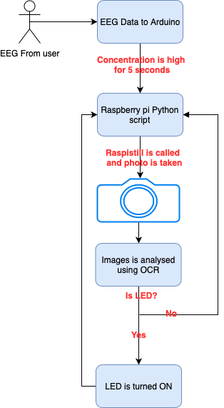

Figure 4.1 methodology for Mind Controlled appliances

Figure 4.1 shows the methodology used to develop a device to provide people with ability to turn appliances ON and OFF just by concentrating on the specific appliance.

The technology used here is Bluetooth to transfer brainwaves over bluetooth to the Arduino micro-controller from EEG. Then the raw brainwaves are converted to numerical format and if concentration is more than the specified than it sends a trigger to the raspberry pi over GPIOs which then triggers a python script.

The script analyse if the concentration to a specific object is more than 5 seconds than the raspberry pi runs a script to take picture of the object which then is analysed by the OCR running with the help of openCV in python environment.

If the text says LED then it triggers and supply the power to the LED, hence result in turning the LED on. If the text is not LED then the scripts run again and stay in a constant loop.